Validation Number and Magic Number Analysis
Submitted By
Name: Abhishek N Shetty
Date: 09/06/2026

Validation Number
A Validation Number is a value used to verify the authenticity, correctness, or integrity of data. It acts as a verification mechanism to ensure that the information being processed is valid and has not been altered.
Validation numbers are commonly used in:
- One-Time Passwords (OTP)
- Verification Codes
- Transaction IDs
- Checksum Validation
- Authentication Systems
- Data Integrity Verification
Example
When a user receives an OTP such as:
456789
The server validates this number before granting access. If the number matches the generated value, the authentication process is completed successfully.

Magic Number
A Magic Number is a unique identifier located at the beginning of a file or data structure. It helps operating systems and applications determine the actual file type regardless of its file extension.
Magic numbers are also known as file signatures.
Common File Magic Numbers
File Type | Magic Number
PDF | %PDF
PNG | 89 50 4E 47
JPEG | FF D8 FF
ZIP | 50 4B 03 04
Example
A PDF file begins with the signature:
%PDF
This signature allows the system to recognize the file as a PDF document even if the file extension has been modified.

Difference Between Magic Number and Validation Number
S.No | Magic Number | Validation Number
1 | A Magic Number is a unique identifier used to recognize a file type or data format. | A Validation Number is used to verify the authenticity, correctness, or integrity of data.
2 | It is usually located at the beginning of a file. | It can appear anywhere within a system or application.
3 | Used for file identification and format recognition. | Used for authentication and data verification.
4 | Generally fixed for a particular file type. | Usually generated dynamically for verification purposes.
5 | Helps operating systems and applications identify the actual file type. | Helps systems verify whether the provided information is valid.
6 | Commonly used in file analysis, malware analysis, and digital forensics. | Commonly used in OTP verification, transaction validation, and authentication systems.
7 | Example: PDF (%PDF), PNG (89 50 4E 47), ZIP (50 4B 03 04). | Example: OTP (456789), Verification Code, Transaction ID.
8 | Used to detect fake or disguised file extensions. | Used to prevent unauthorized access and ensure secure transactions.
9 | Primarily related to file security and identification. | Primarily related to user verification and data integrity.
10 | Remains constant for the same file format. | Changes depending on the verification process or system requirements.

JWT Storage
What is JWT Storage?
JWT Storage refers to the location where a JSON Web Token (JWT) is stored after a user successfully logs into a website or application.
When a user enters valid login credentials, the server generates a JWT and sends it to the user's browser. The browser must store this token somewhere so that it can be sent with future requests to prove the user's identity.
Without storing the JWT, the user would have to log in again for every request made to the server.

Why is JWT Storage Required?
JWT storage is important because it allows websites and applications to:
- Maintain user sessions.
- Verify user identity.
- Provide access to protected resources.
- Avoid repeated logins.
- Support secure authentication mechanisms.

How JWT Storage Works
The JWT authentication process follows these steps:
User Login
↓
Server Verifies Credentials
↓
JWT Generated
↓
JWT Stored in Browser
↓
JWT Sent with Requests
↓
Server Validates JWT
↓
Access Granted

Which Storage Method is Most Secure?
Among the available storage methods, secure HttpOnly cookies are generally considered the safest option because:
- JavaScript cannot directly access the token.
- Risk of token theft through XSS attacks is reduced.
- Additional security flags can be applied.

JWT Storage Analysis
Target: https://flashyre-dev-496807.appspot.com/login

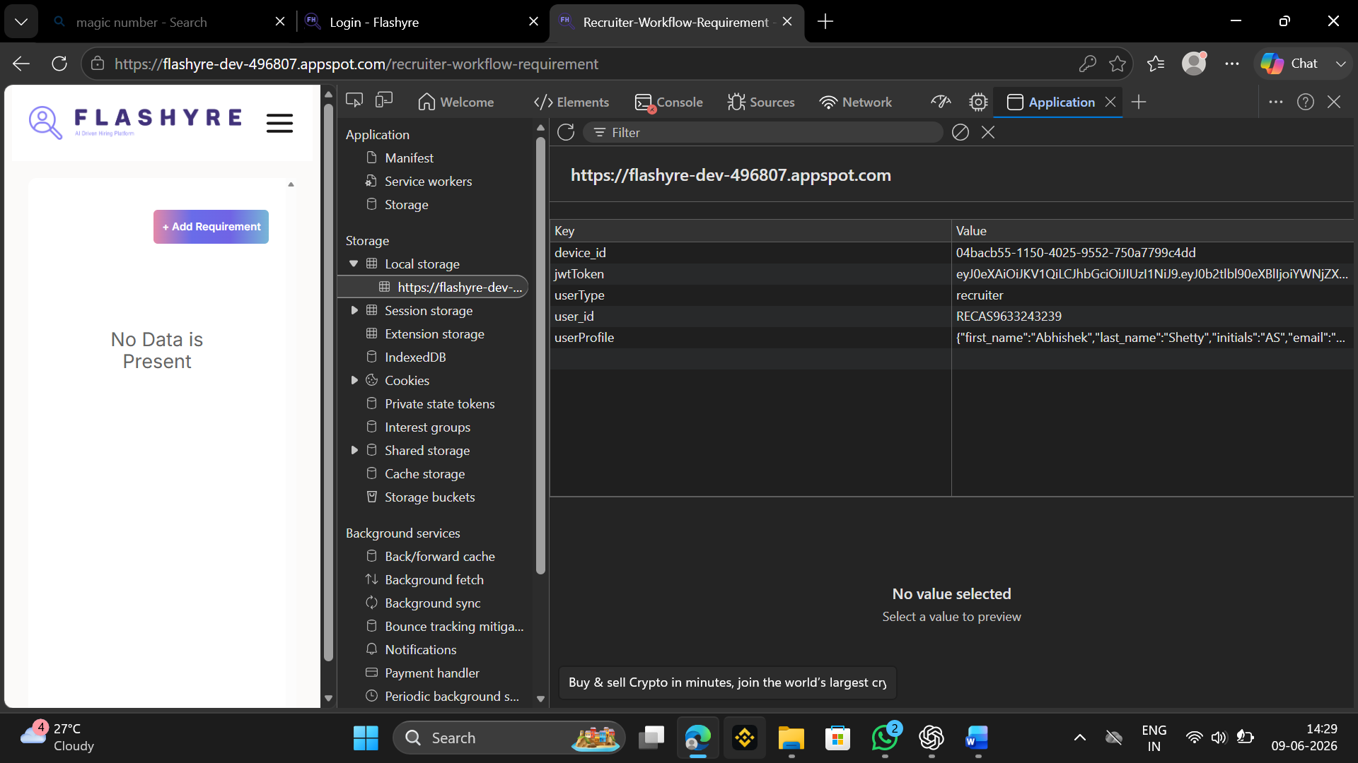

The Application tab of the browser Developer Tools was used to examine the storage mechanisms implemented by the Flashyre web application. During the analysis, the Local Storage section was inspected to identify authentication-related information stored within the browser.

Findings
The analysis of Local Storage revealed multiple stored entries including:
- device_id
- jwtToken
- userType
- user_id
- user Profile

Observation
- JWT token identified in browser Local Storage.
- Authentication token stored under the key jwtToken.
- User profile and session-related information stored locally.
- Local Storage persists data across browser sessions unless manually removed or expired.

